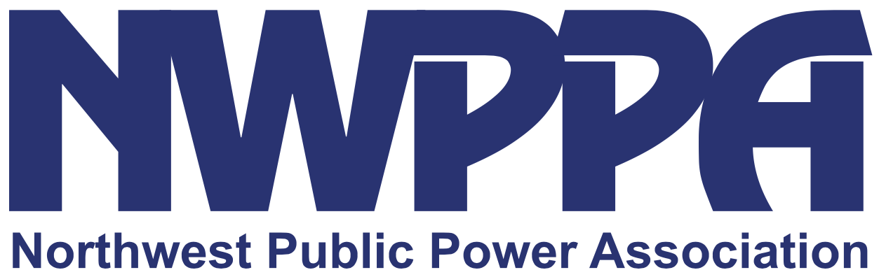
More Powerful Together Leadership Editorial April 2020
EDITORIAL NOTE: This editorial can be used in your publications, on your website or as a good start for a video from your manager to consumers, shared on social media. We’ve looked for examples of how utilities are responding to COVID-19 and provided sample text for several scenarios. Use what works for you.
Fighting COVID-19, we are
More Powerful Together
In an age of social distancing, many of us are scrambling to respond to our new normal. As a [locally owned electric cooperative/community-owned public power utility], we’ve always been driven to help our community grow and meet whatever challenges come our way.

We will get through this, together.

We are monitoring advice from the Centers for Disease Control, World Health Organization, and our state and local governments, and will adjust our practices as needed to follow their guidance. As your community’s energy provider, we are committed to keeping energy flowing. At the same time we’ve taken several steps to preserve community and staff health.

Power On
Many people’s jobs are either lost or suffering a drastic drop in income. You have enough things to worry about right now—you shouldn’t have to worry about losing electricity, too. We temporarily suspended disconnection of service for nonpayment during [MONTHS] and are waiving late fees, too. You are still responsible for the energy that you use, but now you have time to figure out how to move forward.

Pre-paid accounts operate as normal. If you are having trouble paying your bill as a result of COVID-19, we want to work with you. Please call us at (XXX) XXX-XXXX to learn about our long-term payment options and community programs that can help you get back on your feet.

Lobby Closed to Public
As we work to limit person-to-person contact, we made the tough decision to close our offices to the public. But rest assured: we are not closed. Instead of coming to an office to speak to us in person, we encourage you to manage your account from the safety of your home.

Go to our website, [ADDRESS], and use [SmartHub/name of program or prompt] to make payments and track your energy use. If you haven’t done so yet, download our app, which is packed with tools to help you watch and curb your energy use. And remember, you can always call us at (XXX) XXX-XXXX.

If you need to drop off a payment, our [drive-thru kiosk] remains open in [AREA/LOCATION].

Energy Audits Suspended
To respect the CDC’s guidelines for social distancing, we’re suspending our home energy audits program; however, we hope you will still take advantage of our energy efficiency tools and rebates at [website].

As more people spend long days inside and transition to working from home, we expect many homes will use more energy than usual. This will lead to higher energy bills, but there are steps you can take to limit this impact. For more advice on how to use energy efficiently, visit EnergyStar.gov.

Annual Meeting Postponed
In March, federal and state officials declared a state of emergency, asking everyone to help mitigate the spread of COVID-19. In the spirit of cooperation, the [UTILITY] [Board of Directors/Trustees/Commissioners] decided to postpone our [DATE] business meeting.

The health of our community is our top priority. Thanks for your patience as we work together to reduce the risk of this disease spreading in our area. We will reschedule the meeting as soon as it is safe to do so.

Planning Ahead
Because you need energy around the clock, we always have staff on call, ready to respond to any storms or other challenges that come our way. We are still responding to service calls and our normal daily operations, but where we can do so, we’ve scaled down our staff’s exposure to each other, asking some people to work from home. Business travel has been postponed indefinitely as we focus on limiting the spread of COVID-19. We’re rotating our lineworker crews and keeping workspaces sanitized.

I’m not sure what life will look like in the next month, two months, or even a year down the road, but I do know our community. We are resilient. We will adapt. We will get through this.

We may be apart, but we are still—now more than ever—More Powerful Together.

